CUSTOMER SEGMENTATION
USING K-MEANS CLUSTERING
Week 3 Internship Project Report

Internship | Virtual Data Science with Python Trainee
Prepared by | Priyanshu Kumar
Dataset | Mall_Customers.csv (200 customer records)
Tools | Python, Pandas, Matplotlib, scikit-learn, Jupyter Notebook
A data-driven segmentation of customers by annual income and spending behaviour

Executive Summary
In this project, I used K-Means to group the 200 records in the Mall Customers dataset. I focused on two columns: Annual Income (k$) and Spending Score (1–100). After scaling these features, I compared the Elbow curve and Silhouette Scores for different numbers of clusters. Five clusters gave the best Silhouette Score among the tested options (0.5547) and also looked reasonable on the Elbow graph. The groups give a useful picture of different income and spending patterns, although they do not explain why any particular customer behaves that way.
Project measure | Verified result
Original dataset size | 200 rows × 5 columns
Missing values / exact duplicate rows | 0 / 0
Features used for K-Means | Annual Income (k$); Spending Score (1–100)
Selected cluster count | K = 5
Silhouette Score | 0.5547
Exported segmented dataset | Mall_Customers_Segmented.csv — 200 rows × 6 columns

1. Introduction and Objectives
I chose customer segmentation because it is a practical way to apply unsupervised learning to a real dataset. Instead of predicting a known answer, the goal is to find customers who have similar measured characteristics. In this case, I used K-Means to look for patterns in annual income and spending score. These patterns can help a business plan and test more relevant offers, but the data alone cannot tell us the reasons behind a customer’s spending choices.
- Inspect data dimensions, data types, missing values, and duplicate rows.
- Select interpretable numerical features and standardize them before distance-based clustering.
- Use the Elbow Method and Silhouette Score to assess a practical cluster count.
- Visualize and summarize the resulting customer groups.
- Export a reproducible segmented dataset and propose cautious, testable business actions.

2. Dataset Overview and Quality Checks
I started by checking the size of the dataset, its column types, missing values, and duplicate rows. It contains 200 customer records and five original columns. The checks found no null values and no exact duplicate rows, so there was no need to remove records for either of those reasons.
Column | Data type | Role in this project
CustomerID | Integer | Identifier only; excluded from clustering.
Genre | Text/category | Descriptive attribute; not included as a clustering feature.
Age | Integer | Descriptive attribute; not included in this two-feature model.
Annual Income (k$) | Integer | Clustering feature; annual income in thousands of dollars.
Spending Score (1–100) | Integer | Clustering feature; supplied spending score.

The descriptive statistics gave an average customer age of 38.85 years, an average annual income of 60.56 (k$), and an average spending score of 50.20. The dataset also contains 112 records marked Female and 88 marked Male. These figures provide a quick overview of the customers before clustering.

3. Feature Selection and Preprocessing
For the first version of the model, I selected Annual Income (k$) and Spending Score (1–100). I left out CustomerID because it is only an identifier; its numeric value does not describe customer behaviour. I also left out Age and Genre so the analysis would stay focused on income and spending, and so the resulting groups could be shown clearly on a two-dimensional scatter plot.
Before fitting the model, I used StandardScaler to scale both selected features. This step matters because K-Means uses distances to assign customers to clusters, and the two columns should contribute on comparable scales. After scaling, the feature matrix still contained 200 customers and two features.

4. Exploratory Visualization
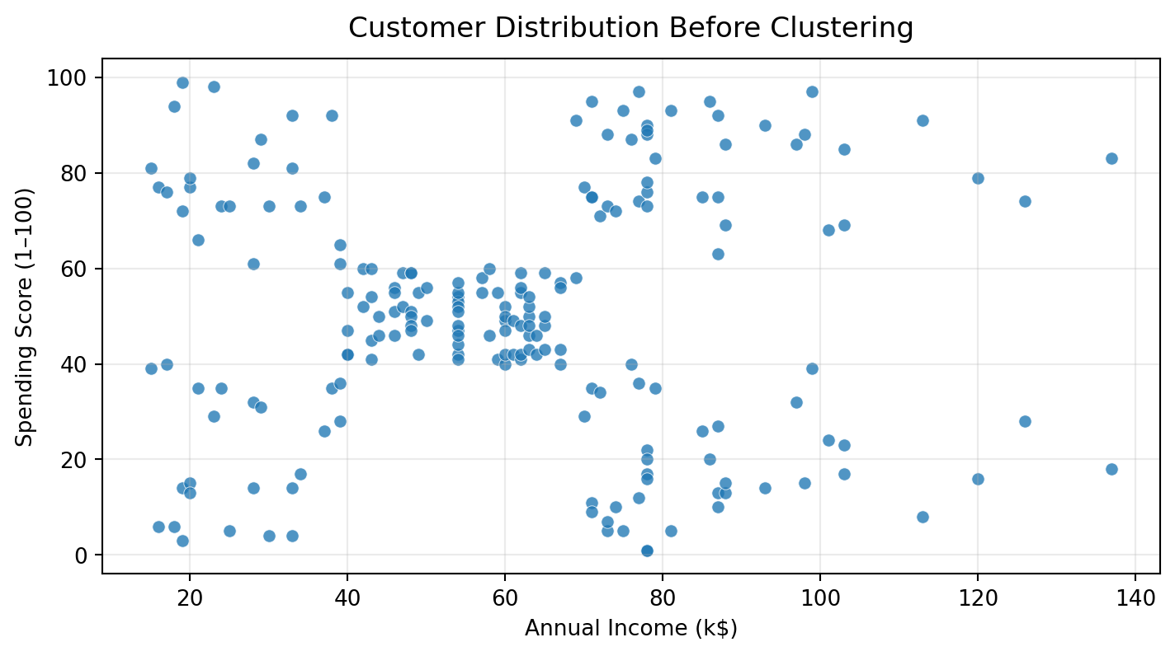
Figure 1. Customer income and spending scores before clustering.
The first scatter plot helped me see how spending scores vary across income levels. Some loose groupings are visible, but looking at the points is not enough to assign customers consistently. I therefore used K-Means on the scaled values to create the cluster labels.

5. Selecting K with the Elbow Method
To choose a reasonable number of clusters, I ran K-Means for values of K from 1 to 10 and recorded the inertia for each run. Inertia decreases as more clusters are added, but the improvement becomes smaller after about K = 5 in my graph. I selected five clusters because the curve begins to flatten around that point. The Elbow Method is a visual guide, so I also checked the Silhouette Scores before settling on the final value.
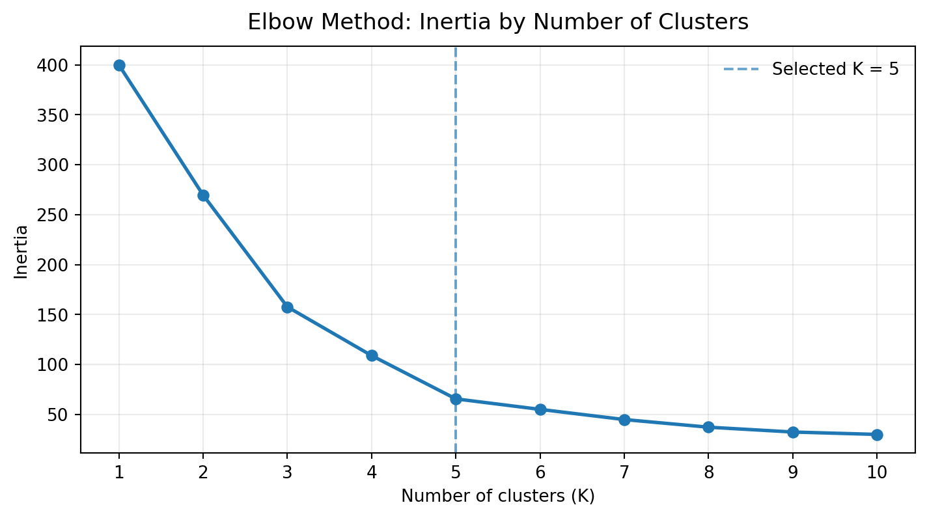
Figure 2. Elbow curve used to help choose K = 5.

6. Model Implementation and Cluster Visualization
I trained the final model with n_clusters = 5, random_state = 42, and n_init = 10. Setting random_state makes the results reproducible, while n_init = 10 lets the algorithm try multiple starting centroid positions. The model assigned each customer a label from 0 to 4. These numbers simply identify the groups; Cluster 4, for example, is not automatically better than Cluster 0.

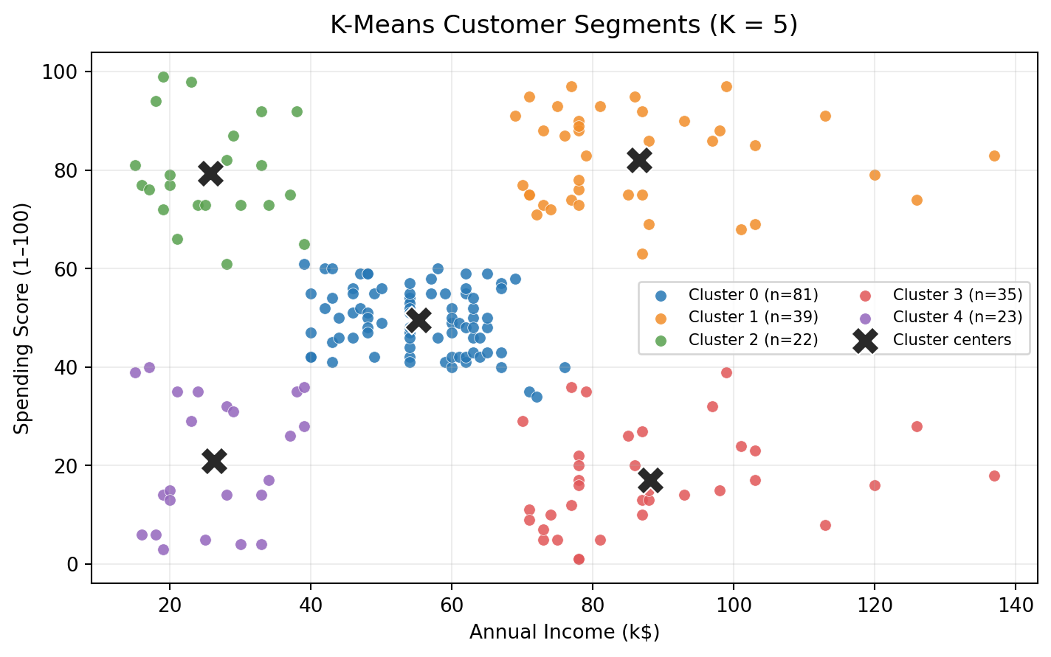
Figure 3. Customer clusters in the original units; X markers show the cluster centres.
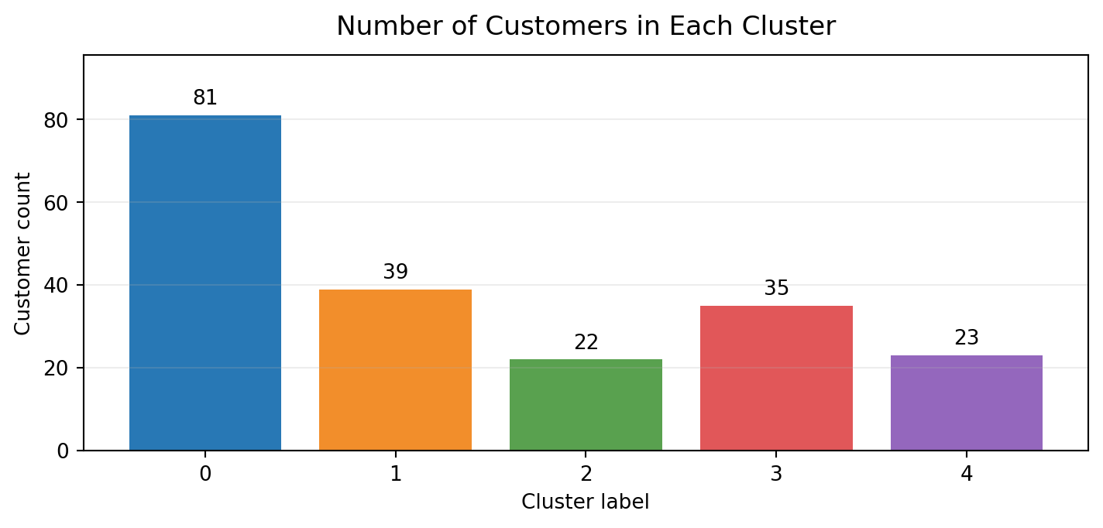
Figure 4. Number of customers in each cluster.

7. Cluster Summary
Cluster | Customers | Avg. age | Avg. income (k$) | Avg. spending
0 | 81 | 42.72 | 55.30 | 49.52
1 | 39 | 32.69 | 86.54 | 82.13
2 | 22 | 25.27 | 25.73 | 79.36
3 | 35 | 41.11 | 88.20 | 17.11
4 | 23 | 45.22 | 26.30 | 20.91

The five cluster counts add up to 200, so every customer in the dataset has been assigned to a group. The averages in the table were calculated from the saved cluster labels and rounded to two decimal places to make them easier to read.

8. Interpretation of Customer Segments

Cluster 0 — Mid-range spending; moderate income
This is the largest group, with 81 customers. Its average income is 55.30 (k$), and its average spending score is 49.52. The group sits around the middle of the spending scale, so a general engagement campaign could be tested. The data does not show what motivates these customers, so campaign results would need to be measured.

Cluster 1 — High income; high spending score
This group contains 39 customers and has both a high average income (86.54 k$) and a high average spending score (82.13). Loyalty rewards, early access to products, or premium offers may be worth testing with this group. I would compare the campaign results before deciding whether to continue these offers.

Cluster 2 — Lower income; high spending score
There are 22 customers in this group. Their average income is 25.73 (k$), while their average spending score is high at 79.36. Affordable bundles or carefully chosen promotions could be tested here. Their lower average income should not be taken to mean that these customers have little value to the business.

Cluster 3 — High income; low spending score
This group has 35 customers, with a high average income of 88.20 (k$) but a low average spending score of 17.11. A short preference survey or more relevant product recommendations could help the business understand what these customers want. The available columns do not explain why their spending score is low.

Cluster 4 — Lower income; low spending score
This group contains 23 customers. Its average income is 26.30 (k$), and its average spending score is 20.91. Value-focused messages may be more suitable than premium offers, but any discount or promotion should be tested to check whether it actually improves engagement.

9. Business Recommendations
- Use the segments to formulate testable marketing hypotheses, not as permanent labels for individual customers.
- Prioritize testing loyalty or premium offers with Cluster 1 and affordable promotional bundles with Cluster 2.
- Explore lower-spending Cluster 3 and Cluster 4 with preference surveys or A/B tests instead of assuming their reasons for low scores.
- Evaluate responses using measurable outcomes such as redemption, conversion, repeat visits, and revenue before scaling an offer.
- Recalculate segments when new customer data becomes available and check whether cluster profiles remain stable.
One point is worth keeping in mind: the dataset does not include campaign results, so it cannot show whether any particular offer will increase sales. The recommendations in this report are ideas to test, not proven outcomes.

10. Model Evaluation
The five-cluster model achieved a Silhouette Score of 0.5547. In general, a score closer to 1 means observations fit their own clusters better than neighbouring clusters, while a score near 0 suggests that groups overlap. The score here is encouraging and suggests a useful level of separation, but it does not mean every point is perfectly placed or that the segments will automatically improve business results.
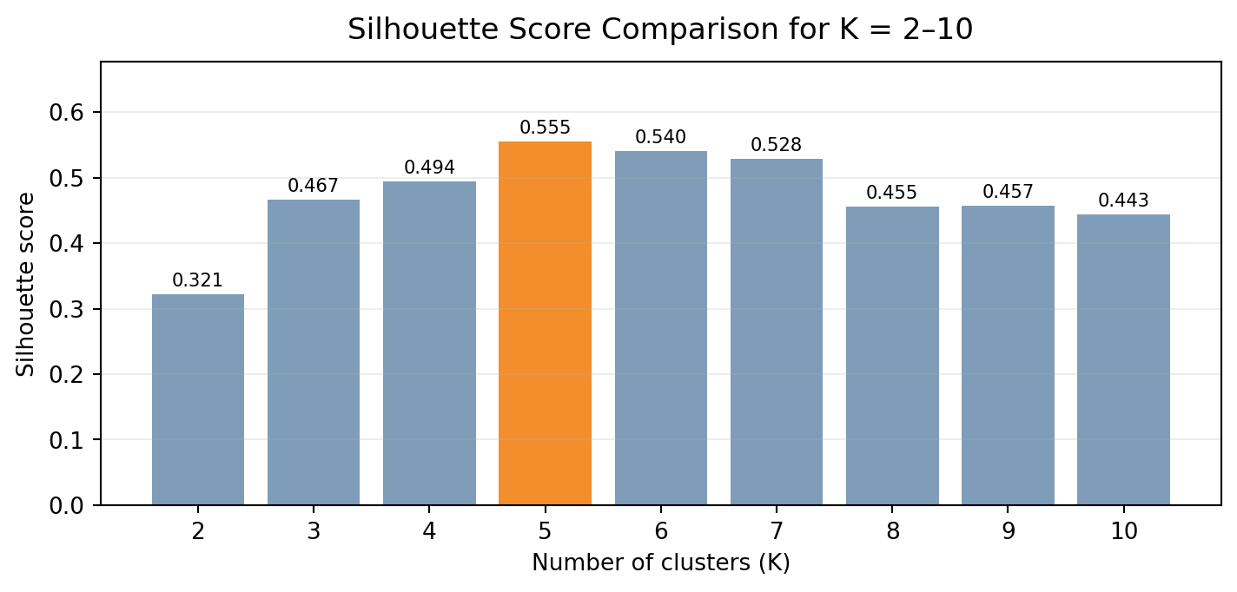
Figure 5. Silhouette Scores for K = 2–10, calculated using the standardized features.
K | Silhouette Score
2 | 0.3213
3 | 0.4666
4 | 0.4939
5 | 0.5547
6 | 0.5399
7 | 0.5281
8 | 0.4552
9 | 0.4571
10 | 0.4432

I also compared Silhouette Scores for K values from 2 to 10. K = 5 gave the highest score in that comparison (0.5547), which supports the choice suggested by the Elbow graph. Using both checks gave me a stronger reason to choose five clusters than relying on the curve alone.

11. Limitations
- Only Annual Income and Spending Score were used for the clustering model; age and genre were descriptive only.
- K-Means favours compact, roughly spherical groups and may not capture every possible pattern in customer behaviour.
- Cluster labels (0–4) are arbitrary and may permute if model settings or data change.
- The dataset is a small educational sample of 200 records; findings should not be generalized to a real mall without validation.
- No demographic or marketing outcome experiment was conducted, so business recommendations remain hypotheses.

12. Conclusion
In this project, I used K-Means to group 200 mall customer records using standardized annual income and spending score. The five-cluster solution produced different average profiles for income and spending, with a Silhouette Score of 0.5547. I saved the cluster labels in Mall_Customers_Segmented.csv and checked the file against the original dataset. Overall, the project gave me practical experience with data preparation, selecting a cluster count, training a model, and explaining the results. The groups could help guide marketing ideas, but any campaign should be tested using real results before it is adopted.

13. Reproducibility and Deliverables
- Week3_Customer_Segmentation_Reviewed.ipynb — organized code, explanations, visualizations, and calculated results.
- Mall_Customers.csv — original 200-row dataset.
- Mall_Customers_Segmented.csv — original fields plus the Cluster label.
Dataset source: Kaggle, “Customer Segmentation Tutorial in Python” — https://www.kaggle.com/datasets/vjchoudhary7/customer-segmentation-tutorial-in-python
Dataset mirror consulted: https://github.com/KIRANSHEHZAD/Customer-Segmentation-Mall
Before submitting, I should save the notebook, run all cells from a fresh kernel, and confirm that the report and CSV show the same results. I should also follow the dataset-source instructions given by the internship and upload the DOCX along with any supporting files or links that the portal asks for.

